TO: All Service Providers
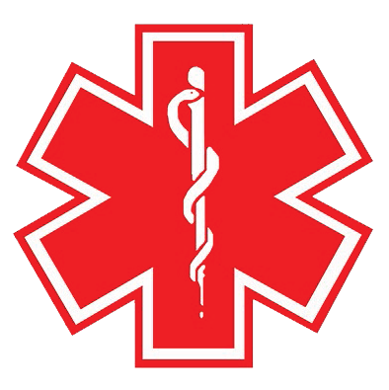

RE: ____________________________________________

The above named patient has a condition known as Multiple Chemical Sensitivities (MCS). Kindly read this carefully and do your best to comply as fully as possible. You may already know that hospitals and service providers are required to accommodate special needs under the Americans with Disabilities Act. Please note that MCS can be life-threatening even though the usual signs of a medical crisis aren't always apparent until extensive damage has already been done.

BASIC STEPS TO ENSURE THIS PATIENT'S SAFETY DURING TREATMENT:

1. Pure air:
- Assign patient to a secluded room or small enclosed area as quickly as possible, isolated from other people, and
when possible, a small room with a window that opens to fresh air. An isolation room is often a good choice.
- Avoid new furnishings, paint, freshly shampooed carpet, air fresheners, new plastics and latex. Avoid alcohol. (Zephiran is the preferred alternative to alcohol for skin antisepsis; hydrogen peroxide is sometimes adequate). Anything with fumes or odor that you can smell will most likely be problematic for this patient.
- Assign staff to this patient who are not wearing cologne or after-shave and tend to use fragrance-free (f.f.) products. (Note: most shaving creams contain fragrance. Two f.f. brands are AVEENO F.F. and HERS F.F. HERS is exactly the same as the men's shave cream.)
- Make oxygen available as soon as possible. (Patient may have brought tubing; if not, older tubing is preferable to newer.)
2. Expedite treatment.
MCS patients are seriously compromised in public buildings.
3. Don't judge patient based on your own sense of smell.
Healthy people often can't smell chemicals that harm MCS patients.
4. Write down any instructions you want the patient to remember.
Chemicals impair brain function and memory in MCS patients. Don't expect the patient to remember, no matter
how clearly you give the instructions.
5. Approach the patient in a calm and supportive manner.
Chemical exposures can cause MCS patients to become anxious, depressed, confused, or even panicky and disruptive. Pay attention to what the patient tells you about immediate needs. Repeat back the main points of what you heard and explain what is being done to accommodate the situation.
6. Flag patient's chart as an MCS reactor.
If patient is to be hospitalized or undergo surgery, assign a patient advocate or social worker to coordinate the extremely daunting preparations for ensuring optimal safety from chemical assaults.

PRIMARY DRUG SENSITIVITIES:

_________________________________________________________________________________________________

_________________________________________________________________________________________________

_________________________________________________________________________________________________

________________________________________________ ____________________________________
Physician’s Signature Date

